**Table of Contents**

1.0 Introduction 6

1.1 Introduction to Business Intelligence Systems 6

1.2 Company Profile 6

1.3 Problem Statement 6

1.4 Assumptions 7

2.0 Aim & Objectives 8

2.1 Aim 8

2.2 Objectives 8

3.0 Methodology – CRISP-DM 9

3.1 Introduction 9

3.2 Phase 1: Business Understanding 10

3.3 Phase 2: Data Understanding 10

3.4 Phase 3: Data Preparation 10

3.5 Phase 4: Modelling 11

3.6 Phase 5: Testing and Evaluation 11

3.7 Phase 6: Deployment 11

4.0 Data Extraction 13

4.1 MSSQL Server 13

4.2 Visual Studio 16

5.0 Modelling 21

5.1 OLAP Cube 21

6.0 MDX Calculations 29

6.1 Internet Sales Gross Profit 29

6.2 Reseller Sales Gross Profit 30

6.3 Total Gross Profit 31

6.4 Total Costs 32

6.5 Total Order Quantity 33

6.6 Total Revenue 34

6.7 Total Orders 35

6.8 Customer Count 36

6.9 Average Order Value 37

6.10 Gross Profit 2022 - KPI 38

6.11 Total Order Quantity 2022 - KPI 39

6.12 Total Revenue 2022 - KPI 40

6.13 Average Order Value 2022 - KPI 41

6.14 Internet Sales 2022 - KPI 42

6.15 Reseller Sales 2022 - KPI 43

6.16 MDX Verification 44

7.0 Visualization 45

7.1 Import Data to Power BI 45

7.2 Dashboard 47

8.0 Analysis 49

8.1 Analytics Overview 49

8.1.1 KPIs 49

8.1.2 Revenue vs Cost Trend 50

8.1.3 Popular Products 52

8.1.4 Customers in Each Region 53

8.1.5 Sales Channel Comparison 54

8.1.6 Sales KPI 54

8.2 Sales 55

8.2.1 Internet vs Reseller Sales Count & Most Sold Products 55

8.2.2 Internet vs Reseller Sales and Gross Profit 56

8.2.3 Internet vs Reseller Revenue by Region 57

8.2.4 Trend of Internet vs Reseller Sales 58

8.3 Customers 59

8.3.1 Customer Gender 59

8.3.2 Sales by Occupation 60

8.3.3 Customer Yearly Income 61

8.3.4 Customer Geographical Distribution 62

9.0 Conclusion 63

9.1 Key Highlights 63

9.2 Interpretations 63

9.3 Recommendations 65

10.0 References 66

**List of Figures**

Figure 1: CRISP-DM Diagram 9

Figure 2: SQL Server Services Running 13

Figure 3: Connecting to MSSQL Server 13

Figure 4: Restoring Velocity Cycles Data Warehouse 14

Figure 5: Data Warehouse Successfully Restored 14

Figure 6: Enter Account Name 15

Figure 7: Enable db_datareader and db_datawriter 15

Figure 8: New Login Created Successfully 15

Figure 9: Creating new Project Using Analysis Services Multidimensional Project Template 16

Figure 10: Configuring Project Name and Location 16

Figure 11: Adding New Data Source in Visual Studio 17

Figure 12: Establishing Connection to SQL Server 17

Figure 13: Select "Use the Service Account" 18

Figure 14: Adding New Data Source View in Visual Studio 18

Figure 15: Selecting Dimension Tables and Fact Tables 19

Figure 16: Data Source and Data Source View Successfully Added 20

Figure 17: Creating New Cube in Visual Studio 21

Figure 18: Select Measure Group Tables 21

Figure 19: Select New Dimensions 22

Figure 20: Complete Cube Creation 22

Figure 21: OLAP Cube 23

Figure 22: Product, Customer, Date, and Reseller Dimensions were Created 23

Figure 23: Adding Attributes for DimProduct1 24

Figure 24: Adding Attributes for DimCustomer 25

Figure 25: Adding Attributes for DimReseller 26

Figure 26: Adding Attributes for DimDate 27

Figure 27: Changing Target Server 28

Figure 28: Build Completed with 0 errors, and Deployment Completed Successfully 28

Figure 29: Internet Sales Gross Profit MDX Expression 29

Figure 30: Reseller Sales Gross Profit MDX Expression 30

Figure 31: Total Gross Profit MDX Expression 31

Figure 32: Total Costs MDX Expression 32

Figure 33: Total Order Quantity MDX Expression 33

Figure 34: Total Revenue MDX Expression 34

Figure 35: Total Orders MDX Expression 35

Figure 36: Customer Count MDX Expression 36

Figure 37: Average Order Value MDX Expression 37

Figure 38: Gross Profit 2022 (KPI) MDX Expression 38

Figure 39: Total Order Quantity 2022 (KPI) MDX Expression 39

Figure 40: Total Revenue 2022 (KPI) MDX Expression 40

Figure 41: Average Order Value 2022 (KPI) MDX Expression 41

Figure 42: Internet Sales Amount 2022 (KPI) MDX Expression 42

Figure 43: Reseller Sales Amount 2022 (KPI) MDX Expression 43

Figure 44: Verifying Calculated Measures 44

Figure 45: Get Data in Power BI 45

Figure 46: Enter Server Name in Power BI 45

Figure 47: Select Velocity Cycles DW in Power BI 46

Figure 48: Data Successfully Imported to Power BI 46

Figure 49: Analytics Overview Dashboard 47

Figure 50: Sales Dashboard 47

Figure 51: Customer Dashboard 48

Figure 52: Analytics Overview – KPI Metrics 49

Figure 53: Analytics Overview – Revenue vs Cost Trend (2020 - 2023) 50

Figure 54: Analytics Overview – Revenue vs Cost Trend (2023) 50

Figure 55: Analytics Overview – Revenue vs Cost Trend (2022) 51

Figure 56: Analytics Overview – Revenue vs Cost Trend (2021) 51

Figure 57: Analytics Overview – Popular Products (Sorted by Orders) 52

Figure 58: Analytics Overview – Popular Products (Sorted by Order Quantity) 52

Figure 59: Analytics Overview – Popular Products (Sorted by Total Revenue) 52

Figure 60: Analytics Overview – Customers in Each Region 53

Figure 61: Analytics Overview – Sales Channel Comparison 54

Figure 62: Analytics Overview – Sales KPI 54

Figure 63: Sales – Internet/Reseller Sales Count & Top 5 Most Sold Products 55

Figure 64: Sales – Internet vs Reseller Sales & Gross Profit 56

Figure 65: Sales – Internet vs Reseller Revenue by Region 57

Figure 66: Sales – Trend of Internet vs Reseller Sales 58

Figure 67: Customer – Gender Segmentation 59

Figure 68: Customer – Sales by Occupation 60

Figure 69: Customer – Yearly Income Distribution 61

Figure 70: Customer – Customer Geographical Distribution 62

# **1.0 Introduction**

## **1.1 Introduction to Business Intelligence Systems**

Business Intelligence (BI) systems are technologies and processes used to collect, integrate, analyse, and present business data (Ain et al., 2019). The main objective of BI is to transform unstructured data into insightful knowledge in order to facilitate better decision-making. Dashboards, reporting tools, data warehouses, and analytical models are common components of BI systems, which assist businesses in tracking performance, spotting patterns, and making strategic plans. BI gives companies a clear picture of how their business is operating, helping them react to opportunities and challenges more skilfully (El-Adaileh & Foster, 2019).

## **1.2 Company Profile**

Velocity Cycles is a company specializing in manufacturing bicycles and components. They have gained a reputation for developing high-quality products thanks to their integrity towards innovation, precision engineering, and customer satisfaction. The business has established a strong domestic presence and a strong supply chain and distribution network that guarantee prompt delivery and reliable quality. Their product line serves both recreational and expert cyclists, establishing them as a reliable name in the market. Currently, Velocity Cycles is working to increase its presence in international markets, specifically in North America, Europe, and the Asia-Pacific area, as part of their growth strategy.

## **1.3 Problem Statement**

Velocity Cycles faces a challenge in understanding its overall business performance across diverse markets. Its data is scattered across departments, making it difficult to gather valuable insights for decision-making. Without a centralized database to analyse sales trends and customer behaviours, the company is taking a huge risk in making uninformed decisions which could lead to business failures. Therefore, Velocity Cycles has decided to implement business intelligence to solve this issue using a multi-dimensional modelling approach, which can help them visualize data from multiple perspectives.

## **1.4 Assumptions**

The following assumptions are made:

* Gross Profit is measured based on sales amount vs product standard cost, not the unit cost. This is because unit cost may vary due to price fluctuations and inefficiencies, so using the standard cost can enable consistency in generating internal reports.
* If sales amount exceeds the product standard cost for a product, then the product is assumed to have met its KPI.
* Average Order Value will focus on online sales channels since internet sales is going to be more popular in the future (will be discussed in a later section), so it will only consider internet sales and internet orders.
* The business’s KPIs for total order quantity, total gross profit, total revenue, average order value, internet sales amount, and reseller sales amount are set based on the data from the previous year (2022), with a small 10% increase because it is assumed that the company is focused on growth as well as stability. Only with a stable performance can the company consider expanding to other areas.
* The business’s performance such as the total order quantity, total gross profit, total revenue, average order value, internet sales amount, and reseller sales amount will be analysed based on whether the 2023 data reached the KPIs. This is because the data in 2024 is incomplete, so we will use the most recent and complete data which is 2023 data.

# **2.0 Aim & Objectives**

## **2.1 Aim**

The aim of this project is to utilize business intelligence tools and techniques to gain comprehensive insights into Velocity Cycles' performance, sales patterns, and customer behaviour, in order to support data-driven decision-making that enhances profitability, optimizes operations, and aligns the company’s strategies with evolving market trends.

## **2.2 Objectives**

* To evaluate the overall business performance of Velocity Cycles using key performance indicators (KPIs).
* To analyse sales trends across channels, regions, and product categories to identify growth opportunities and optimize marketing and inventory strategies.
* To understand customer demographics and behaviour to improve targeting, satisfaction, and sales strategy.

# **3.0 Methodology – CRISP-DM**

## **3.1 Introduction**

Cross-Industry Standard Process for Data Mining (CRISP-DM) was chosen as the methodology for this project. This methodology is widely used in the industry for developing data-driven projects as well as business intelligence solutions (Casonatto et al., 2024). CRISP-DM is split into 6 phases: business understanding, data understanding, data preparation, modelling, evaluation, and deployment and the process is run iteratively. One key strength of this methodology is its flexibility, where it is not tied to any specific industry or tool, allowing it to adapt to various BI scenarios (Schröer et al., 2021). Besides that, the iterative nature of this methodology ensures that the model is continuously refined to adapt to environments where the data source may evolve over time. By adopting CRISP-DM, the BI initiative can remain focused, transparent, and outcome-driven throughout the project lifecycle.

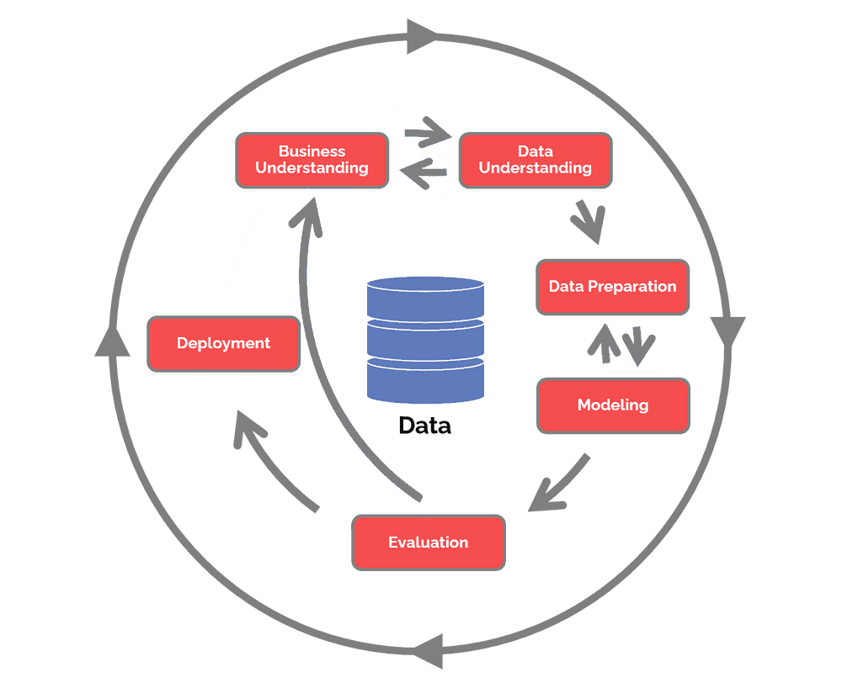

Figure 1: CRISP-DM Diagram

## **3.2 Phase 1: Business Understanding**

The initial phase focuses on understanding the company’s goals, needs, and challenges. In the context of Velocity Cycles, the objective is to support strategic global expansion by gaining deeper insights into its company, like its current business performance, customer preferences, and market trends. As the BI Consultant, this phase involves identifying key performance indicators (KPIs), defining analytical goals, and aligning them with business strategies—such as increasing market share in Europe or optimizing the supply chain for Asia-Pacific.

## **3.3 Phase 2: Data Understanding**

Next comes the data understanding phase, where the most relevant data is collected and explored to identify potential data quality issues or variable relationships. Using the Velocity Cycles data warehouse, this phase involves examining tables related to sales (Internet sales, reseller sales), customers, products, geography, and time. Any patterns or missing values in these tables will be analysed using different types of visualizations to ensure that the data is suitable for BI analysis. For example, customer purchasing behaviour by region can be explored using a map chart, which helps assess readiness for market segmentation or pricing strategies.

An important thing to note is that the findings from this phase may reveal some gaps or limitations that were not initially discovered in the business understanding phase, so it may be necessary to revisit the business goals and adjust them based on the new requirements. This iterative feedback loop ensures that the project aligns with business needs and data constraints.

## **3.4 Phase 3: Data Preparation**

Data preparation is conducted to clean, transform, or reduce data so that it is suitable for analysis. It is imperative that there exists a comprehensive understanding of the business goals and data because this phase is non-reversible. Once data has been transformed and restructured, returning to raw form can be complex or impractical without restarting the process, so the data must be error-free before moving forward. That is why the first 3 phases of this methodology take up majority of the total project time (85%).

At Velocity Cycles, this phase involves tasks such as imputing missing values, correcting inconsistencies and outliers, selecting relevant attributes, or normalizing skewed columns. Dimensional modelling is also applied to organize the data into well-structured fact and dimension tables, such as Internet Sales Fact, Product Dimension, Customer Dimension, and more. This will allow for multi-dimensional analysis to be conducted.

## **3.5 Phase 4: Modelling**

This phase involves applying analytical or data mining techniques to discover patterns and generate insights. In a BI context, this could include creating Online Analytical Processing (OLAP) cubes, dashboards, KPIs, or visualizations to monitor performance and trends. This phase is flexible, where it allows analysts to return to the data preparation phase and choose different measures or dimensions if the current model does not effectively answer the intended questions.

For Velocity Cycles, models could be used to track sales performance across regions or identify top performing products in each region. It is even possible to compare customer behaviour across demographic segments.

## **3.6 Phase 5: Testing and Evaluation**

In this phase, models created from the previous phase are evaluated to ensure that they meet the business objectives. For Velocity Cycles, this might mean verifying that the dashboards accurately highlight sales trends and product performance. Stakeholders assess whether the analysis aligns with expectations and supports strategic decision-making.

If the evaluation reveals that the findings do not align with the business goals, the project may return to the first phase of business understanding. This allows for a reassessment of business questions or refinement of objectives, ensuring that the BI solution remains relevant before it is finalized for deployment.

## **3.7 Phase 6: Deployment**

Finally, the BI solution is implemented and presented in a way the decision maker can understand and benefit from even if they are not tech savvy. At Velocity Cycles, this includes rolling out dashboards, scheduled reports, or interactive BI tools to managers and executives. However, it is important to note that this is not the end of the data mining project. Over time, models built on the present data may become obsolete or irrelevant. Therefore, maintenance must be conducted regularly to ensure that the models can adapt to ever-changing data and reflect newer and actionable insights.

# **4.0 Data Extraction**

## **4.1 MSSQL Server**

1. Ensure that these 4 SQL Server Services are running.

Figure 2: SQL Server Services Running

1. Connect to MSSQL Server using the server name that was created (.\NEWSQLSERVER) and ensure that “Trust server certificate” is selected.

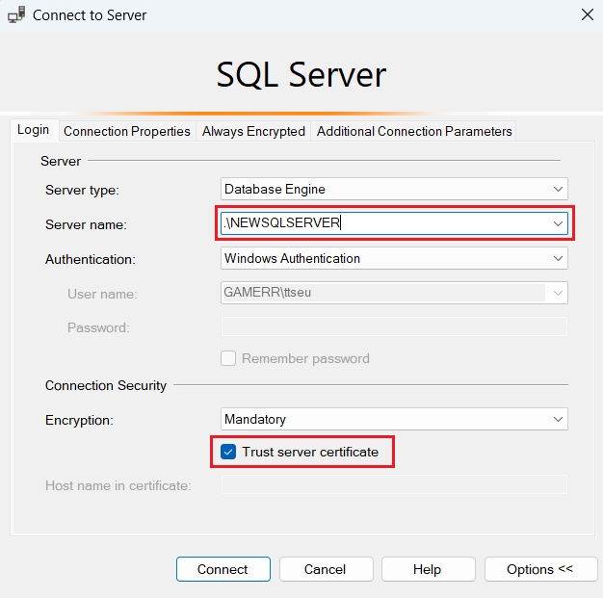

Figure 3: Connecting to MSSQL Server

1. Restore the VelocityCycles data warehouse that is located in the local files.

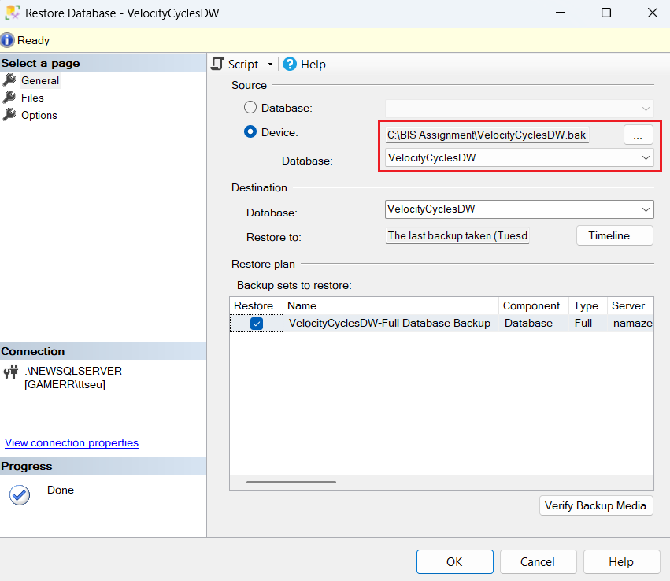

Figure 4: Restoring Velocity Cycles Data Warehouse

1. The data warehouse should now appear under the “Databases” folder.

Figure 5: Data Warehouse Successfully Restored

1. Create a new login by entering the account name of MSSQL Server Analysis Services as the login name in the “General” tab and map the new user to the login while also enabling db_datareader and db_datawriter functions.

|  |  |
| --- | --- |
| Figure 6: Enter Account Name | Figure 7: Enable db_datareader and db_datawriter |

1. The new login should now appear under the “Security” 🡪 “Logins” folder.

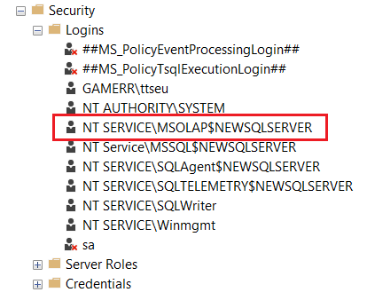

Figure 8: New Login Created Successfully

## **4.2 Visual Studio**

1. Create a new project using the “Analysis Services Multidimensional Project” template.

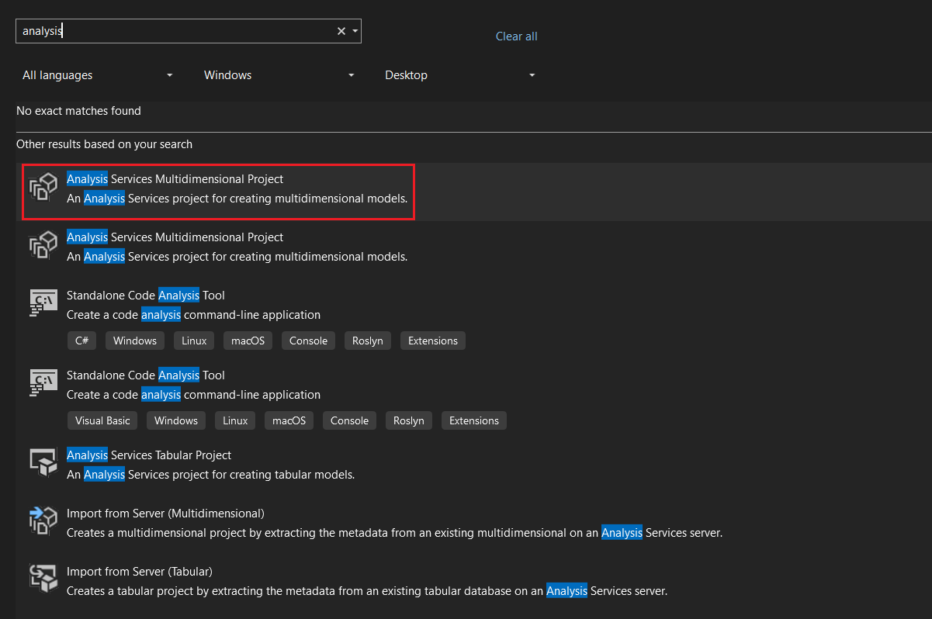

Figure 9: Creating new Project Using Analysis Services Multidimensional Project Template

1. Rename the project and select a location to create the new project.

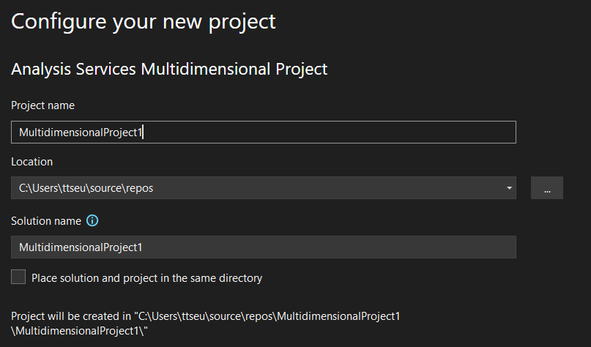

Figure 10: Configuring Project Name and Location

1. In the project solution explorer, right click on Data Sources to add a new data source.

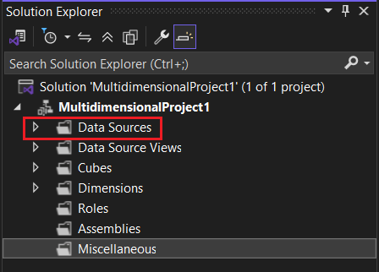

Figure 11: Adding New Data Source in Visual Studio

1. Change the provider to SQL Client Data Provider, then the server’s name to the MSSQL Server name mentioned previously. Lastly, select the velocity cycles data warehouse to establish a connection.

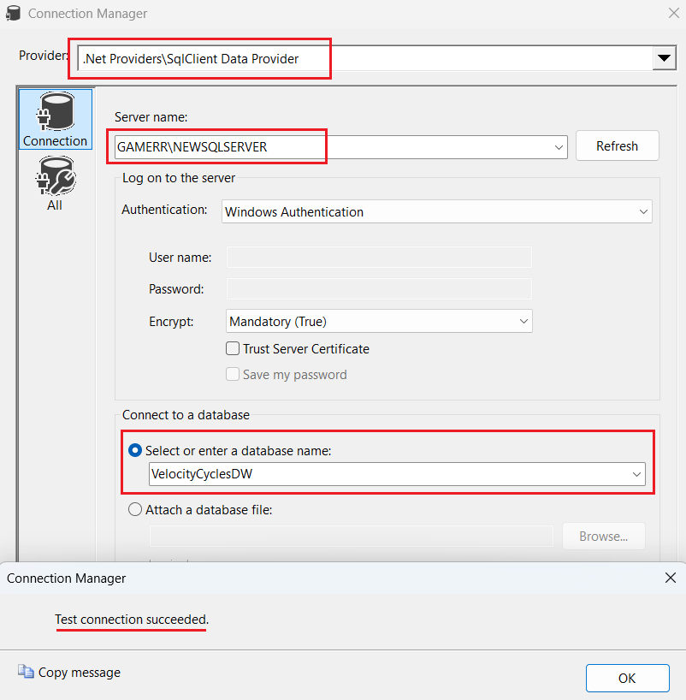

Figure 12: Establishing Connection to SQL Server

1. Select “Use the service account” option and proceed.

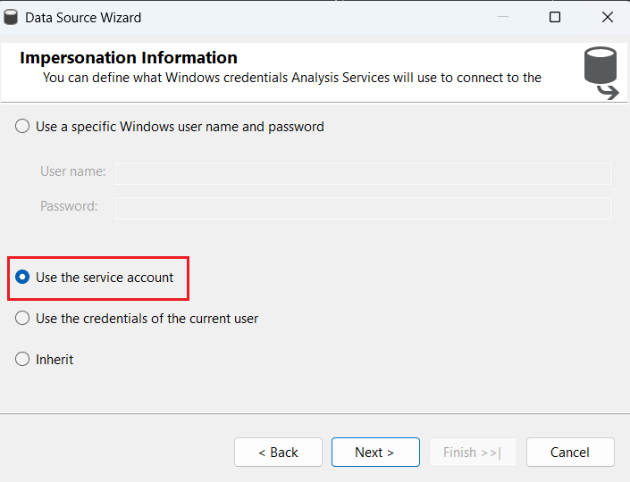

Figure 13: Select "Use the Service Account"

1. Next, right click on Data Source Views to add a new data source view.

Figure 14: Adding New Data Source View in Visual Studio

1. According to our aims, the following dimension tables and fact tables are selected: DimCustomer, DimDate, DimGeography, DimProduct, DimReseller, FactInternetSales, and FactResellerSales.

Figure 15: Selecting Dimension Tables and Fact Tables

1. Since there are currently no relationships between DimDate and other dimensions, some new relationships were created to help link the tables. To link DimDate with Fact ResellerSales and FactInternetSales, the OrderDateKey column was used as the source and the DateKey column was used as the destination.

1. Now, the data source should be connected successfully, and the data source view should be created as well.

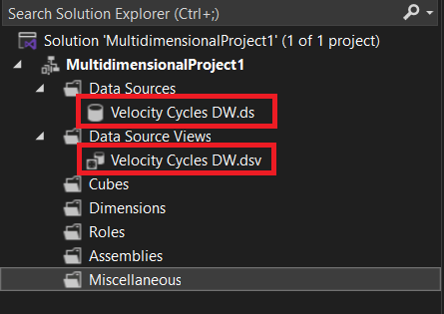

Figure 16: Data Source and Data Source View Successfully Added

# **5.0 Modelling**

## **5.1 OLAP Cube**

1. In Visual Studio, right click on Cubes to create a new OLAP cube.

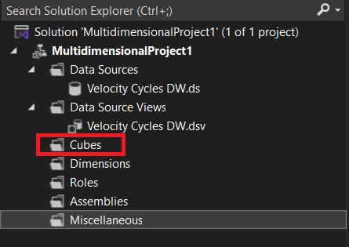

Figure 17: Creating New Cube in Visual Studio

1. Select the fact tables as the tables that will be used for measure groups.

Figure 18: Select Measure Group Tables

1. Select the dimension tables as the tables that will be used to create new dimensions.

Figure 19: Select New Dimensions

1. Name the cube and click “Finish” to create the cube.

Figure 20: Complete Cube Creation

1. The OLAP cube is now created. Along with 4 dimensions Dim Product 1, Dim Customer, Dim Date, and Dim Reseller.

Figure 21: OLAP Cube

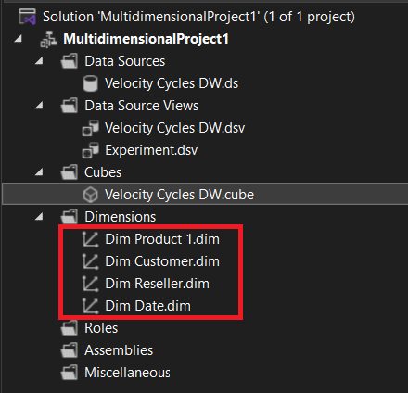

Figure 22: Product, Customer, Date, and Reseller Dimensions were Created

1. For Dim Product 1, the following attributes were added:

* EnglishProductName
* StandardCost
* Color
* ListPrice
* DaysToManufacture
* EnglishDescription

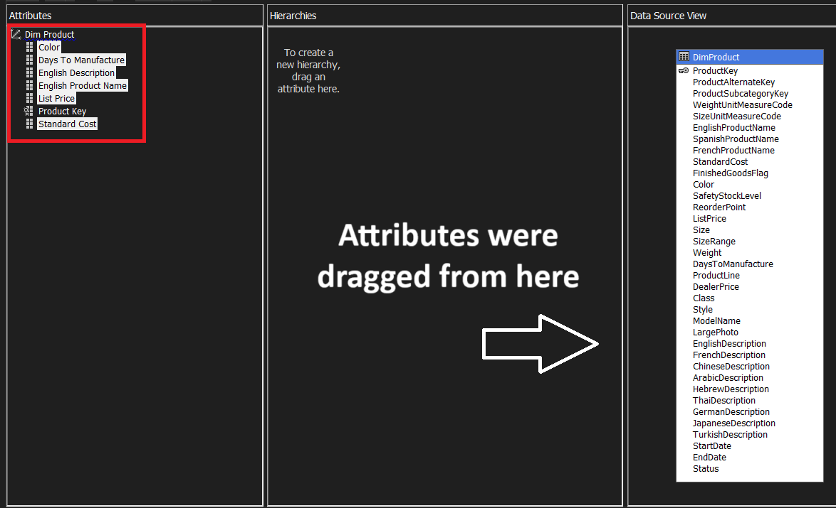

Figure 23: Adding Attributes for DimProduct1

1. For the customer dimension, it carries the geography dimension as the grain. The following attributes were added for the customer dimension:

* BirthDate
* MaritalStatus
* Gender
* EmailAddress
* YearlyIncome
* TotalChildren
* NumberChildrenAtHome
* EnglishEducation
* EnglishOccupation
* HouseOwnerFlag
* NumberCarsOwned
* Phone
* DateFirstPurchase
* CommuteDistance

As for the geography dimension, the following attributes were added:

* City
* EnglishCountryRegionName

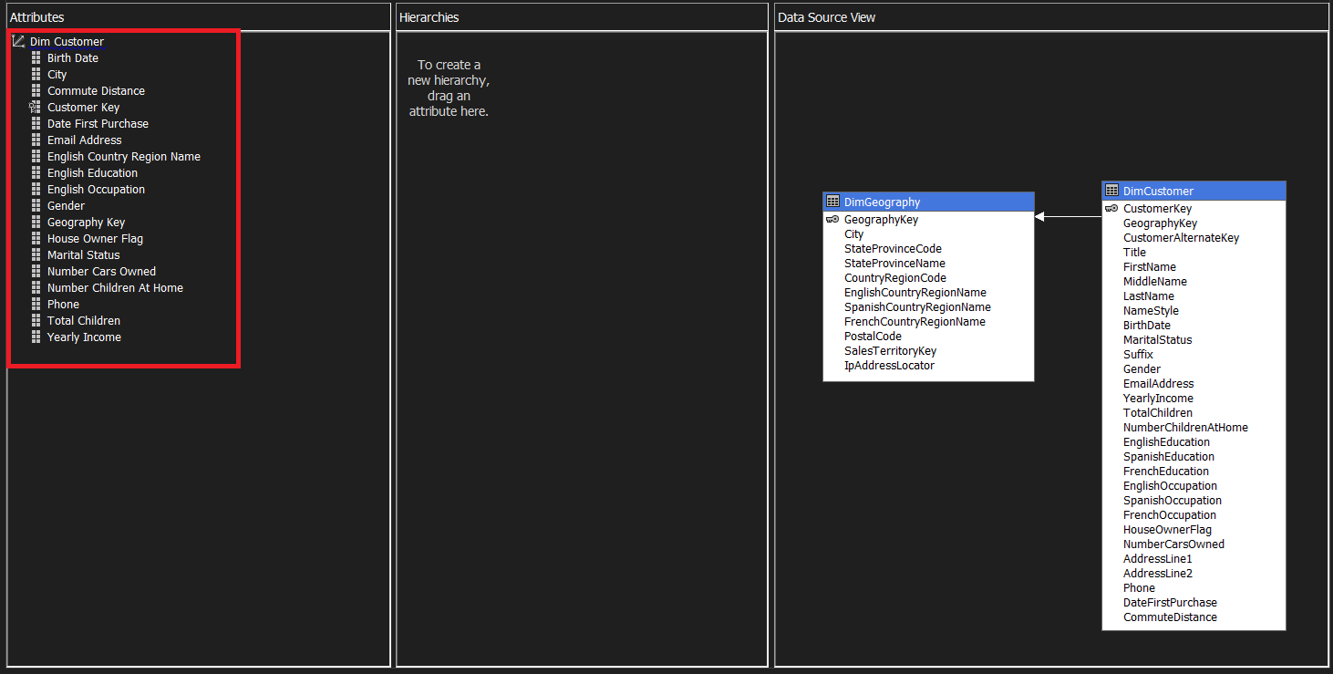

Figure 24: Adding Attributes for DimCustomer

1. For the reseller dimension, it carries the geography dimension as the grain as well. The following attributes were added for the reseller dimension:

* BusinessType
* ResellerName
* NumberEmployees
* OrderFrequency
* AnnualSales
* AnnualRevenue

As for the geography dimension, the following attributes were added:

* City
* EnglishCountryRegionName

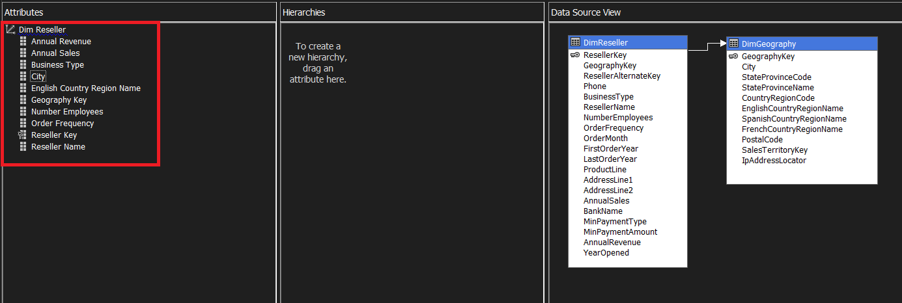

Figure 25: Adding Attributes for DimReseller

1. For Dim Date, the following attributes were added:

* Calendar Quarter
* Calendar Semester
* Calendar Year
* Date Key
* Day Number Of Month
* Day Number Of Week
* English Day Name Of Week
* English Month Name
* Fiscal Quarter
* Fiscal Semester
* Fiscal Year
* Month Number Of Year
* Week Number Of Year

Figure 26: Adding Attributes for DimDate

1. Finally, we move on to deploying the project. We first have to change the target server to the server name mentioned previously.

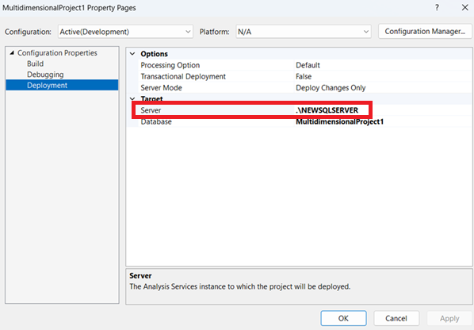

Figure 27: Changing Target Server

1. We select “Build Project”, then “Deploy Project”. The process runs without errors, showing that the cube was created successfully.

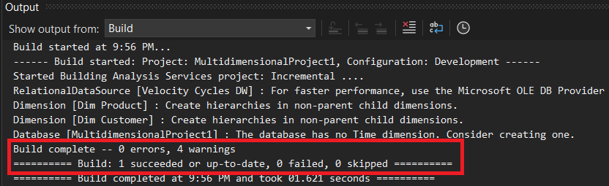

Figure 28: Build Completed with 0 errors, and Deployment Completed Successfully

# **6.0 MDX Calculations**

## **6.1 Internet Sales Gross Profit**

Expression:

[Measures].[Sales Amount] - [Measures].[Total Product Cost]

Figure 29: Internet Sales Gross Profit MDX Expression

## **6.2 Reseller Sales Gross Profit**

Expression:

[Measures].[Sales Amount - Fact Reseller Sales] - [Measures].[Total Product Cost - Fact Reseller Sales]

Figure 30: Reseller Sales Gross Profit MDX Expression

## **6.3 Total Gross Profit**

Expression:

([Measures].[Sales Amount] + [Measures].[Sales Amount - Fact Reseller Sales]) - ([Measures].[Total Product Cost] + [Measures].[Total Product Cost - Fact Reseller Sales])

Figure 31: Total Gross Profit MDX Expression

## **6.4 Total Costs**

Expression:

[Measures].[Total Product Cost] + [Measures].[Total Product Cost - Fact Reseller Sales]

Figure 32: Total Costs MDX Expression

## **6.5 Total Order Quantity**

* The total of order quantity in internet sales and reseller sales for each product.

Expression:

[Measures].[Order Quantity] + [Measures].[Order Quantity - Fact Reseller Sales]

Figure 33: Total Order Quantity MDX Expression

## **6.6 Total Revenue**

* The sum of sales amount in internet sales and reseller sales for each product.

Expression:

[Measures].[Sales Amount] + [Measures].[Sales Amount - Fact Reseller Sales]

Figure 34: Total Revenue MDX Expression

## **6.7 Total Orders**

Expression:

[Measures].[Fact Internet Sales Count] + [Measures].[Fact Reseller Sales Count]

Figure 35: Total Orders MDX Expression

## **6.8 Customer Count**

Expression:

DISTINCTCOUNT(EXISTING([Dim Customer].[Customer Key].[Customer Key]))

Figure 36: Customer Count MDX Expression

## **6.9 Average Order Value**

Expression:

[Measures].[Sales Amount] / [Measures].[Order Quantity]

Figure 37: Average Order Value MDX Expression

## **6.10 Gross Profit 2022 - KPI**

This expression calculates the gross profit of 2022 and multiplies it by 10% to set a realistic target for the KPI. Other KPIs in this section follow the same principle.

Expression:

1.1 * (

(

([Measures].[Sales Amount], [Dim Date].[Calendar Year].&[2022]) +

([Measures].[Sales Amount - Fact Reseller Sales], [Dim Date].[Calendar Year].&[2022])

) -

(

([Measures].[Total Product Cost], [Dim Date].[Calendar Year].&[2022]) +

([Measures].[Total Product Cost - Fact Reseller Sales], [Dim Date].[Calendar Year].&[2022])

)

)

Figure 38: Gross Profit 2022 (KPI) MDX Expression

## **6.11 Total Order Quantity 2022 - KPI**

Expression:

1.1 * (

(

([Measures].[Order Quantity], [Dim Date].[Calendar Year].&[2022]) +

([Measures].[Order Quantity - Fact Reseller Sales], [Dim Date].[Calendar Year].&[2022])

)

)

Figure 39: Total Order Quantity 2022 (KPI) MDX Expression

## **6.12 Total Revenue 2022 - KPI**

Expression:

1.1 * (

(

([Measures].[Sales Amount], [Dim Date].[Calendar Year].&[2022]) +

([Measures].[Sales Amount - Fact Reseller Sales], [Dim Date].[Calendar Year].&[2022])

)

)

Figure 40: Total Revenue 2022 (KPI) MDX Expression

## **6.13 Average Order Value 2022 - KPI**

Expression:

1.1 * (

(

[Measures].[Sales Amount],

[Dim Date].[Calendar Year].&[2022]

)

/

(

[Measures].[Order Quantity],

[Dim Date].[Calendar Year].&[2022]

)

)

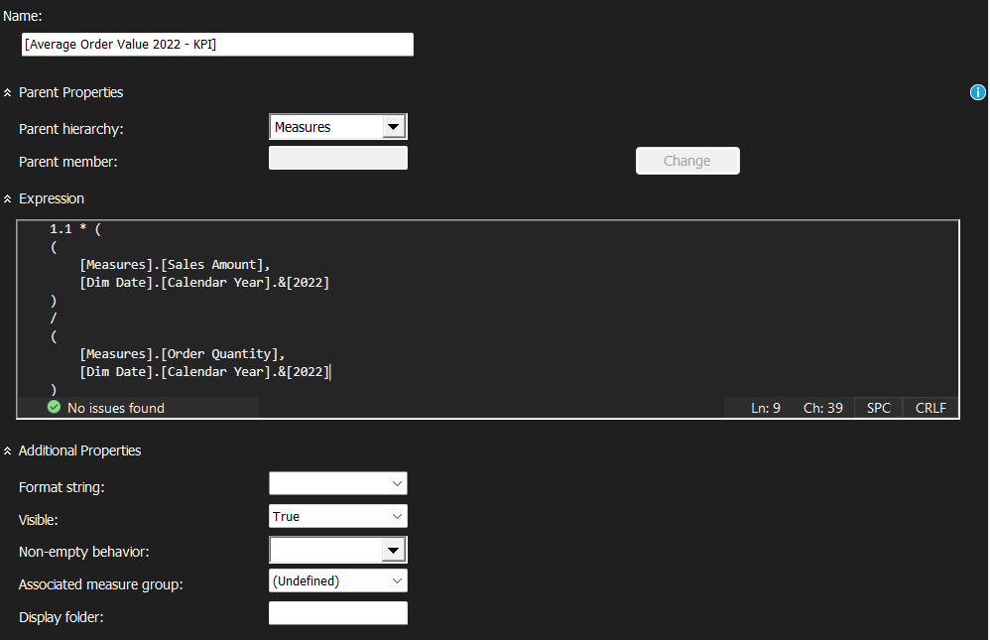

Figure 41: Average Order Value 2022 (KPI) MDX Expression

## **6.14 Internet Sales 2022 - KPI**

Expression:

1.1 * (([Measures].[Sales Amount], [Dim Date].[Calendar Year].&[2022]))

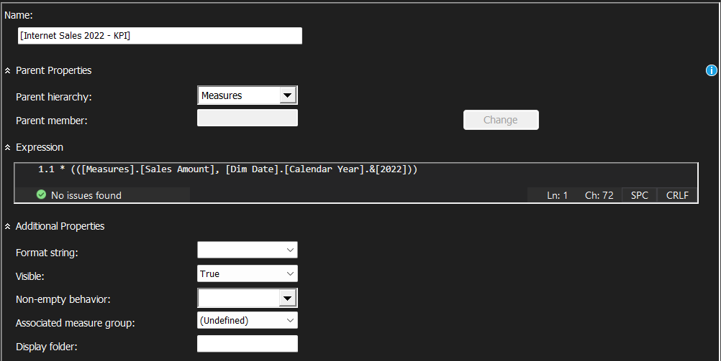

Figure 42: Internet Sales Amount 2022 (KPI) MDX Expression

## **6.15 Reseller Sales 2022 - KPI**

Expression:

1.1 * (([Measures].[Sales Amount - Fact Reseller Sales], [Dim Date].[Calendar Year].&[2022]))

Figure 43: Reseller Sales Amount 2022 (KPI) MDX Expression

## **6.16 MDX Verification**

To check if the MDX expressions were implemented successfully, we can go to the “Browser” tab and input the calculated measures as a query, which will display the calculated values. For example, we can display the gross profit as well as the sales amount and total product cost, so we can manually calculate and verify if the gross profit is accurately displayed.

Figure 44: Verifying Calculated Measures

# **7.0 Visualization**

## **7.1 Import Data to Power BI**

1. First, create a new project and select “SQL Server Analysis Services database” in the “Get Data” page.

Figure 45: Get Data in Power BI

1. Then, enter the server name mentioned previously and select “Connect live”.

Figure 46: Enter Server Name in Power BI

1. Select the Velocity Cycles data warehouse and proceed.

Figure 47: Select Velocity Cycles DW in Power BI

1. The data should now be successfully imported into Power BI.

Figure 48: Data Successfully Imported to Power BI

## **7.2 Dashboard**

Figure 49: Analytics Overview Dashboard

Figure 50: Sales Dashboard

Figure 51: Customer Dashboard

# **8.0 Analysis**

## **8.1 Analytics Overview**

### **8.1.1 KPIs**

Figure 52: Analytics Overview – KPI Metrics

The values above are the KPI metrics for Velocity Cycles in 2023. According to the cards, Velocity Cycles has exceeded the goals for total order quantity, total gross profit, and total revenue by quite a significant amount. This is a good sign that the company is performing well since it is making more money than it expected. On the other hand, the average order value (AOV), which is the average amount a customer spends on one order, has declined considerably (83.6%), but it is not necessarily a bad thing. Even though the AOV is lower, the revenue and profits have increased, meaning that the number of orders must have increased substantially. However, it could also mean that customer buying habits have changed to ordering more frequently, but with smaller baskets. This may not be as beneficial for the company because more orders mean more shipping and handling costs which can erode margins, so the company should consider incentivizing customers to add more items to carts through bundles or introduce a minimum order threshold for an added benefit like free shipping.

### **8.1.2 Revenue vs Cost Trend**

Figure 53: Analytics Overview – Revenue vs Cost Trend (2020 - 2023)

According to the line chart, Velocity Cycle has observed a continuous year-over-year growth from 2020 to 2023. The revenue from 2020 has also more than doubled over the years, and the gap between revenue and costs has been increasing as well, signifying a strong business growth momentum overall.

Figure 54: Analytics Overview – Revenue vs Cost Trend (2023)

Figure 55: Analytics Overview – Revenue vs Cost Trend (2022)

Figure 56: Analytics Overview – Revenue vs Cost Trend (2021)

However, when we drill down to the statistics in each year (2023, 2022, 2021), we see that there is a significant dip in revenue for Q3 consistently. This shows that Q3 tends to be a weak quarter for Velocity Cycles, potentially affected by external market factors. The company should consider more promotions and marketing campaigns during this period to increase the demand.

### **8.1.3 Popular Products**

Figure 57: Analytics Overview – Popular Products (Sorted by Orders)

Figure 58: Analytics Overview – Popular Products (Sorted by Order Quantity)

Figure 59: Analytics Overview – Popular Products (Sorted by Total Revenue)

|  |  |
| --- | --- |
| **Product Type** | **Role** |
| Water Bottle – 30 oz | Most ordered |
| AWC Logo Cap | Most units ordered |
| Mountain-200 Black, 38 | Highest revenue & margin |

Even though the water bottle and the cap are the most ordered products, the revenue generated from them is on the lower end, showing that they are lower margin products. The company should use these products to offer bulk pricing to increase AOV. On the other hand, the higher margin products like the bikes should be promoted heavily by highlighting its features and customer testimonials since they bring in the most revenue.

### **8.1.4 Customers in Each Region**

Figure 60: Analytics Overview – Customers in Each Region

This table shows that the majority of customers for Velocity Cycles come from the United States (US). The company should therefore strengthen its US brand presence to make the brand feel more homegrown and credible. One example is that they could include US-based ambassadors to promote their products, like former professional cyclist Lance Armstrong.

### **8.1.5 Sales Channel Comparison**

Figure 61: Analytics Overview – Sales Channel Comparison

Overall, the number of sales from the internet and from resellers are quite balanced. This will be analysed further later on.

### **8.1.6 Sales KPI**

Figure 62: Analytics Overview – Sales KPI

The internet sales and reseller sales have shown to have reached its KPI goal, which was set at the standard product cost. Not only did they break even, but they also even exceeded the target by a large margin especially for reseller sales.

## **8.2 Sales**

### **8.2.1 Internet vs Reseller Sales Count & Most Sold Products**

Figure 63: Sales – Internet/Reseller Sales Count & Top 5 Most Sold Products

|  |  |
| --- | --- |
| **Sales Channel** | **Top 5 Products** |
| Internet Sales | 1. Water Bottle – 30 oz. 2. Patch Kit/8 Patches 3. Mountain Tire Tube 4. Road Tire Tube 5. Sport-100 Helmet, Red |
| Reseller Sales | 1. AWC Logo Cap 2. Long-Sleeve Logo Jersey, L 3. Sport-100 Helmet, Blue 4. Sport-100 Helmet, Black 5. Sport-100 Helmet, Red |

The analysis shows that online customers prefer to purchase items that assist in self-service repairs, implying that online customers are more focused on utility and maintenance. As for the reseller customers, they prefer to purchase wearable items like helmets. This is because those items require trying on for comfort or size, so purchasing in-store is a safer approach. Therefore, the company should prioritize maintenance items for internet stores while shipping more helmets and apparels to reseller locations to ensure that they carry all the different sizes of popular apparel. Since the demand for these items have been established, there will be less chances of losing out on potential sales due to inadequate stock, and customer satisfaction will improve across both channels as well.

### **8.2.2 Internet vs Reseller Sales and Gross Profit**

Figure 64: Sales – Internet vs Reseller Sales & Gross Profit

In 2023, reseller sales and internet sales both met their KPI targets, which is based on 2022 data. Reseller sales are shown to still be the dominant sales channel by generating the most revenue. However, internet sales have grown a lot more compared to the sales in 2022 than reseller sales, which could suggest that the internet channel is growing faster and more efficiently. Furthermore, the overall gross profit from internet sales far surpasses those in reseller sales, likely due to the fact that internet stores have higher margins thanks to lower operating costs and the absence of reseller cuts.

### **8.2.3 Internet vs Reseller Revenue by Region**

Figure 65: Sales – Internet vs Reseller Revenue by Region

|  |  |  |
| --- | --- | --- |
| **Region** | **Internet Sales** | **Reseller Sales** |
| United States | 9,389,789.51 | 53,607,801.21 |
| Australia | 9,061,000.58 | 1,594,335.38 |
| United Kingdom | 3,391,712.21 | 4,279,008.83 |
| France | 2,644,017.71 | 4,607,537.93 |
| Canada | 1,977,844.86 | 14,377,925.60 |
| Germany | 2,894,312.34 | 1,983,988.04 |

From this table, some important insights can be made. For example, the United States brings the most revenue and is reseller driven thanks to its incredibly high reseller sales. The same can be said for Canada, where the reseller sales heavily outweigh the internet sales. This suggests that the reseller network in these regions is highly developed and trusted, so the company should continue investing in reseller support in the US and Canada to ensure customers continue to receive the best experience.

On the contrary, some regions have higher internet sales, like Australia where their internet sales are 5.7 times higher than reseller sales. Regions with this characteristic likely have strong online shopping culture or good logistics and delivery culture. Based on that, the company should prioritize e-commerce investment in these regions, which includes advertisements and localized web content.

### **8.2.4 Trend of Internet vs Reseller Sales**

Figure 66: Sales – Trend of Internet vs Reseller Sales

This area chart shows that at the start, reseller sales outpaced internet sales significantly. In 2022, reseller sales peaked but dipped in 2023. Meanwhile, the steady growth in internet sales year by year eventually allowed it to overtake reseller sales in 2023. This chart shows a clear shift in consumer preference toward online shopping as the world moves to a more modern and digital environment. It also shows that customers could have more confidence in buying online, meaning that the current e-commerce strategy is effective.

## **8.3 Customers**

### **8.3.1 Customer Gender**

Figure 67: Customer – Gender Segmentation

Velocity Cycles has around 18 thousand customers, which is a solid customer base. By grouping the customer by gender, it can be seen that the gender ratio is quite balanced with a slight female majority. This means that the company should consider marketing that targets both genders.

### **8.3.2 Sales by Occupation**

Figure 68: Customer – Sales by Occupation

This donut chart shows that the company’s products are mainly purchased by professionals, skilled manual workers, and people from management backgrounds. These are likely customers with stable income and active lifestyles, ideal for sports and cycling products. They are also the main consumer base that the company should target with their marketing campaigns.

### **8.3.3 Customer Yearly Income**

Figure 69: Customer – Yearly Income Distribution

The income distribution shows that the peak clusters are in the 20000 to 90000 range, with over 2000 to 3000 customers each. Income below 30k and above 120k have minimal representation. There are also very few customers that fall into high-income brackets of above 150k. This shows that Velocity Cycle’s target demographic is middle-income people so their pricing and marketing should focus on value-for-money, durability, and functionality.

### **8.3.4 Customer Geographical Distribution**

Figure 70: Customer – Customer Geographical Distribution

As shown previously, most of Velocity Cycle’s customers are located in the United States. This just visualizes the data in a map form.

# **9.0 Conclusion**

## **9.1 Key Highlights**

* KPIs were not only met but also exceeded.
* AOV is low but number of orders increased. This results in more operational costs, so the company needs to increase AOV by implementing bundles or minimum order threshold for free shipping.
* Revenue is growing.
* Q3 consistently dips in revenue and requires an increase in marketing.
* Lower margin products like water bottles and caps are ordered frequently, so the company should offer bulk pricing to increase AOV.
* Bikes are higher margin products and should be marketed more to bring in more profits.
* Most customers are in the US, signifying the need for a stronger US brand presence.
* Internet sales focus on utility and maintenance items.
* Reseller sales focus on wearables. The company needs to stock according to demand.
* Internet sales are growing faster and generate more gross profit.
* US and Canada is reseller based; Australia is more internet based.
* Internet sales show steady growth, surpassing reseller sales in 2023.
* Customer gender is evenly split; the company must target both males and females.
* The company should target professionals and skilled manual workers.
* They should price the products to be more affordable and ensure that the product is durable to cater to middle-income customers.

## **9.2 Interpretations**

The analysis revealed that Velocity Cycles has exceeded KPIs for total order quantity, gross profit, and revenue in 2023, indicating strong financial performance. However, the AOV has dropped by 83.6%, so the company should start introducing bundle deals and free shipping thresholds to discourage customers from placing small orders which can increase operational costs. Bulk pricing should also be implemented on lower margin goods that are frequently purchased such as water bottles and caps to increase the AOV. Apart from that, it was observed that the third quarter Q3 performs badly compared to other quarters, which shows that the company should increase their marketing campaigns during this period. The marketing should focus on higher margin products such as their bikes to rake in more profits.

When comparing internet sales and reseller sales, it was found that online customers prefer buying utility and maintenance items, whereas reseller customers prefer wearables and apparel items where they can try on sizes in person. Therefore, the Velocity Cycles should amend their stock allocation according to this difference in demand to ensure that customer’s needs are always fulfilled and leave feeling satisfied. Besides that, the analysis revealed that internet sales are growing much faster than reseller sales – surpassing reseller sales in sales count in 2023 thanks to its steady growth, and it also generates more profits too. This suggests that the company’s e-commerce strategy is quite effective and that customers are starting to shift towards online shopping trends, so the company should act accordingly by putting more attention towards internet stores. However, the company should still focus on reseller stores, especially in US and Canada, where the main sales channel is reseller sales by a huge margin. As for regions where online shopping is more prevalent, like Australia, the company can consider investing more towards internet selling methods and online ad campaigns.

Lastly, the analysis shows that the customer base for Velocity Cycles is largely comprised of those in the US, implying that the company should strengthen its brand presence in that area. When segmenting the customers by gender, the gender ratio for customers was discovered to be quite balanced, meaning that the company should cater its products for both male and female audiences equally. Other segments also revealed that the company’s revenue mostly come from middle-income professionals and skilled workers, so the company should price their products more affordably and emphasise on product durability to target these customer groups.

With these positive growth trends in mind, the company should proceed with expanding its operations both geographically and digitally to capitalize on its momentum.

## **9.3 Recommendations**

1. To address the decrease in average order value (AOV), the company should start introducing bundle deals and free shipping thresholds to discourage customers from placing small orders, especially on lower margin goods that are frequently purchased such as water bottles and caps.
2. Since Q3 consistently underperforms, the company should focus more on marketing and promotions on high margin products like their bikes during this period to increase sales. They can target their most common consumer base, which are middle-income professionals and skilled workers by pricing their products more affordably and emphasise on product durability. They could also do more social media promotions since internet sales have shown to be increasing in popularity, especially in regions like Australia where internet is the main sales channel.
3. Regarding internet and reseller sales channels, internet sales is growing in popularity and also generate more profits due to less operational costs. Therefore, the company should invest in better internet shopping services while also not forgetting about reseller sales since their main region (US) is reseller-based (53 million revenue). For countries that have more revenue from internet sales, like Australia, the company can focus their efforts more on internet stores.
4. There is a trend where Internet sales focus on utility and maintenance items, while Reseller sales focus on wearables. The company needs to stock according to demand to ensure that customer’s needs are always fulfilled and leave feeling satisfied. For example, more helmets and jerseys can be shipped to US and Canada stores since they are more reseller based, while more tire tubes can be shipped to internet-sales-based countries like Australia.

# **10.0 References**

Ain, N., Vaia, G., DeLone, W. H., & Waheed, M. (2019). Two decades of research on business intelligence system adoption, utilization and success – A systematic literature review. *Decision Support Systems*, *125*(1). <https://doi.org/10.1016/j.dss.2019.113113>

Casonatto, R. A., De, T., & Mariano, A. M. (2024). Quality and Risk Management in Data Mining: A CRISP-DM Perspective. *Procedia Computer Science*, *242*, 161–168. <https://doi.org/10.1016/j.procs.2024.08.257>

El-Adaileh, N. A., & Foster, S. (2019). Successful business intelligence implementation: a systematic literature review. *Journal of Work-Applied Management*, *11*(2), 121–132. Emerald. <https://doi.org/10.1108/jwam-09-2019-0027>

Schröer, C., Kruse, F., & Gómez, J. M. (2021). A Systematic Literature Review on Applying CRISP-DM Process Model. *Procedia Computer Science*, *181*(1), 526–534. <https://doi.org/10.1016/j.procs.2021.01.199>

Metre, K. V., Mathur, A., Dahake, R. P., Bhapkar, Y., Ghadge, J., Jain, P., & Gore, S. (2023). An Introduction to Power BI for Data Analysis. International Journal of Intelligent Systems and Applications in Engineering, 12(1s), 142–147. Retrieved from <https://ijisae.org/index.php/IJISAE/article/view/3401>